What is a chalazion?
A chalazion is a small lump that can appear within the eyelid as a result of a blocked Meibomian gland. The lump is a mix of secretion and semi-solid gelatinous material (Meibomian lipogranuloma). More commonly occurring on the upper eyelid, a chalazion may resolve without treatment but if persisting is often a cause of irritation and a visible lump. Chalazia can also become inflamed or infected.
How to treat it?

Chalazia which are obviously infected may well resolve with antibiotics or warm compresses. Surgical treatment should be reserved for cases failing to resolve after any acute infection. We would recommend treatment for chalazia that persist beyond six weeks.

If a chalazion does not resolve itself, it can be treated surgically under local anaesthetic. The eyelid is anaesthetised and then a clamp applied to the eyelid. A small cut is made inside the eyelid which avoids a visible scar. The liquefied secretion is expressed, and any gelatinous and fibrous material is then removed using a curette (a small spoon shaped instrument). This reduces the size of the lump significantly but does not remove it completely.

Treated chalazia are unlikely to recur but patients who suffer from them are susceptible to further chalazia in the future.

Sometimes despite appropriate incision and curettage, a fibrous lump remains and additional treatments with steroid injections or excision and biopsy may be recommended. This is more difficult, and this service does not treat recurrent or atypical Chalazia. We can recommend an oculoplastic surgeon.

After the chalazion removal
The following guidelines tell you what to expect after your operation and will help you look after your eye and wound after surgery.
Wear an eye pad to stop bleeding and swelling. One will be provided at your appointment which will be secured with tape or a head bandage. Keep it on for 6 hours or overnight if your procedure was late afternoon.

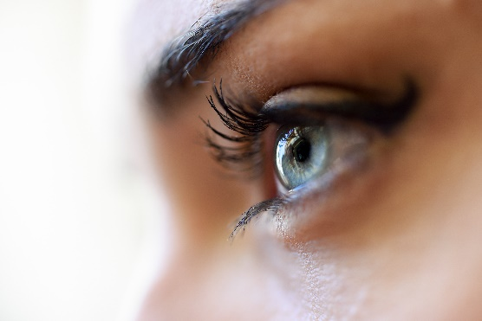
Do not drive – use public transport or arrange for someone to accompany you to your appointment until you can remove your eye pad.

Use antibiotic eye ointment twice daily for 5 days. The first does will be given to you at your appointment.

Avoid manual and outdoor work for 24 hours but you can return to your other usual activities. For a week after the procedure, dust or debris in your eye would increase the small rick of post-operative infection.

The area around your eye is likely to be sore and your eyelid will be swollen for 2-3 days. You may also have some visible bruising on the lid and below the eye for about one week.

If you have any concern following the procedure, please contact the GP Care office or, if out of hours, please contact 111.

Contact us.

Clinic Location
Litfield House Medical Centre Tel: 0333 332 2107 www.gpcare.org.uk
Litfield Place, Clifton Down, Bristol
BS8 3LS

